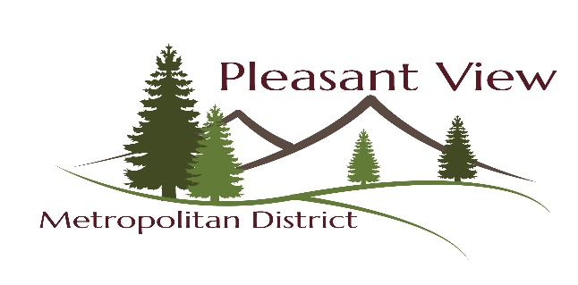
BOARD OF DIRECTORS MEETING AGENDA
August 18, 2020 6:00 p.m.

Regular Meeting of the Board of Directors of the Pleasant View Metropolitan District
955 Moss St. Golden, CO 80401

1. Call to Order

2. Roll Call: Adrian Waller, Tiffany Smith, Devin Keen, Julie Shaw, Jennie Heismann

3. Pledge of Allegiance

4. Approval of Agenda

5. Approval of Minutes: July 21, 2020

6. Correspondence:

7. Reports: A. Treasurers Report F. Parks/Recreation/Facilities
B. Bills Paid G. Building Committee
C. Bills to be Paid H. Personnel: Sick/Vacation Report
D. Bank & CC Reconciliations I. Work Logs
E. Fire Department

8. New Business:
1.

9. Old Business:
1. SDA 2020

10. Executive Session:

11. Public Comments:

The public comment section offers an opportunity for any citizen to express opinions or ask questions regarding District services, policies, or other matters of community concern and any agenda items that are not a part of a scheduled public hearing. Citizens have three minutes for comments if they are speaking as an individual, or 5 minutes if speaking on behalf of a group or organization. These time limits were established to provide efficiency in the conduct of the meeting and to allow equal opportunity for everyone wishing to speak. An immediate response should not be expected, as issues are typically referred to District staff for follow-up or research and then reported back to the Board and the individual who initiated the comment or inquiry. Anyone who wishes to make a public comment must sign in on the Public Comment Sign-Up List. When it is time, the speaker will come to the lectern, state their name, address, and make their comment. A board member will start a timer and notify when time is up if needed. Questions and comments will be recorded. Audience members speaking out of turn will be asked not to speak out of order. If audience members continue to be out of order, they will be asked to leave the meeting.

12. Adjournment

The next Regular Board Meeting of the Pleasant View Metropolitan District Board of Directors is scheduled for Tuesday, September15, 2020 at 6:00 p.m. at the District Office at 955 Moss Street, Golden, CO 80401

